# Scenario#1: WAZI Developer for VS Code

STEP-1: Check assigned issue and import application

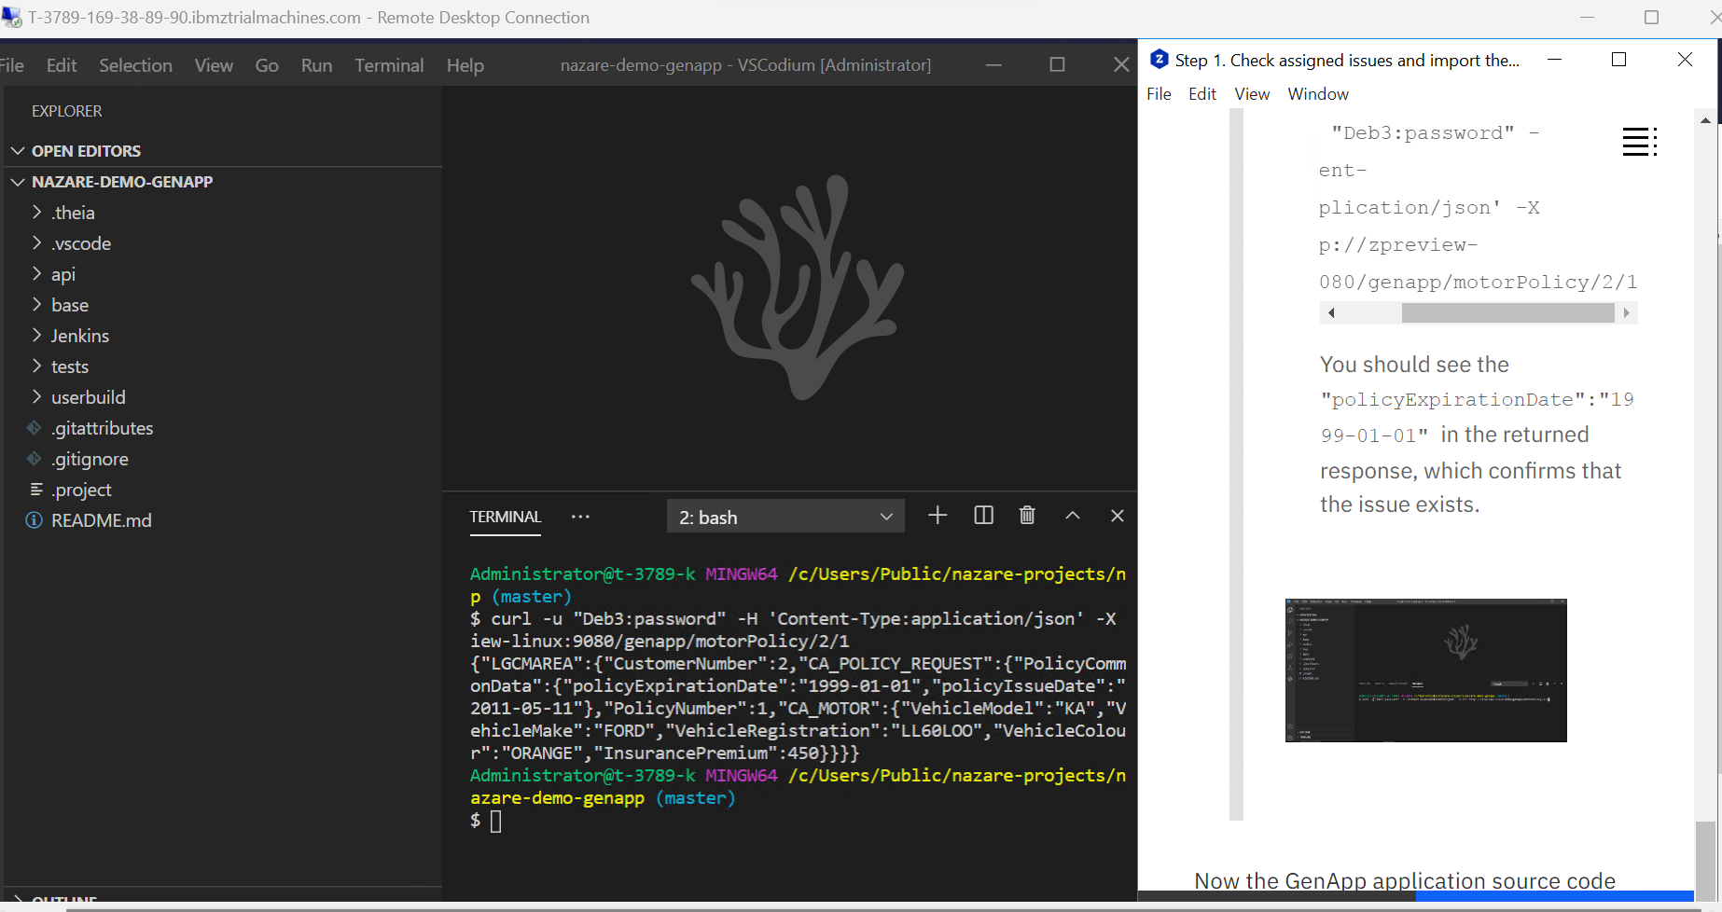

STEP-2: Debug the Code

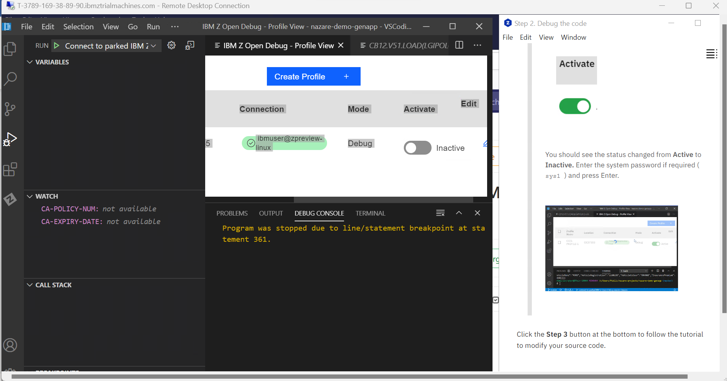

STEP-3: Change the Code

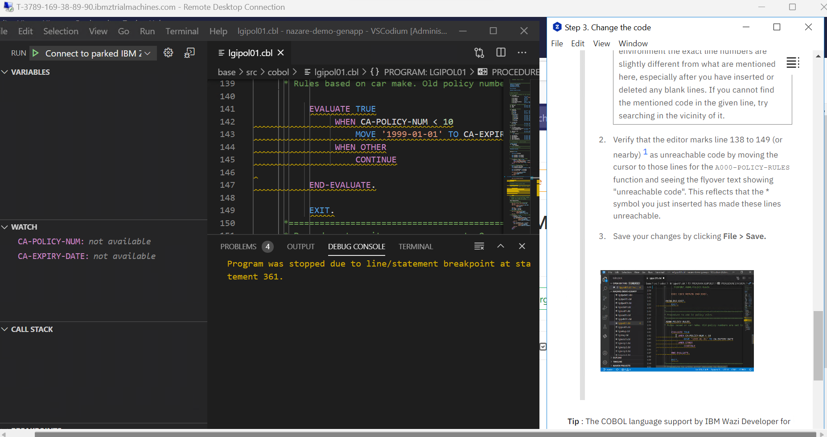

STEP-4: Run a build to test change code

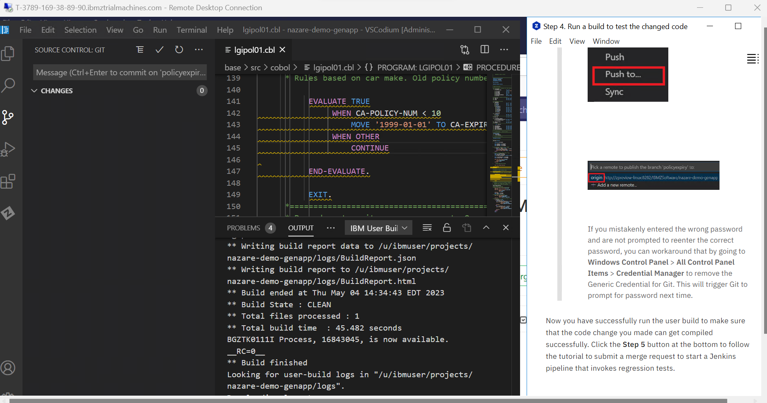

STEP-5: Run Regression test and merge your change

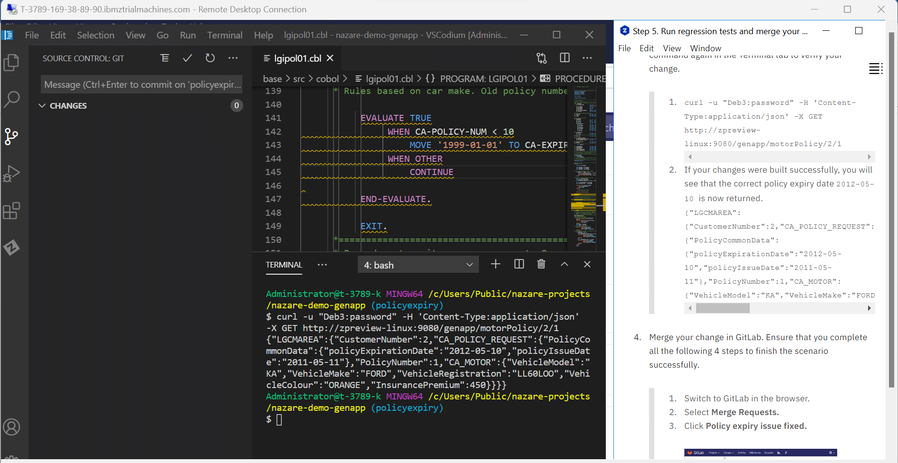

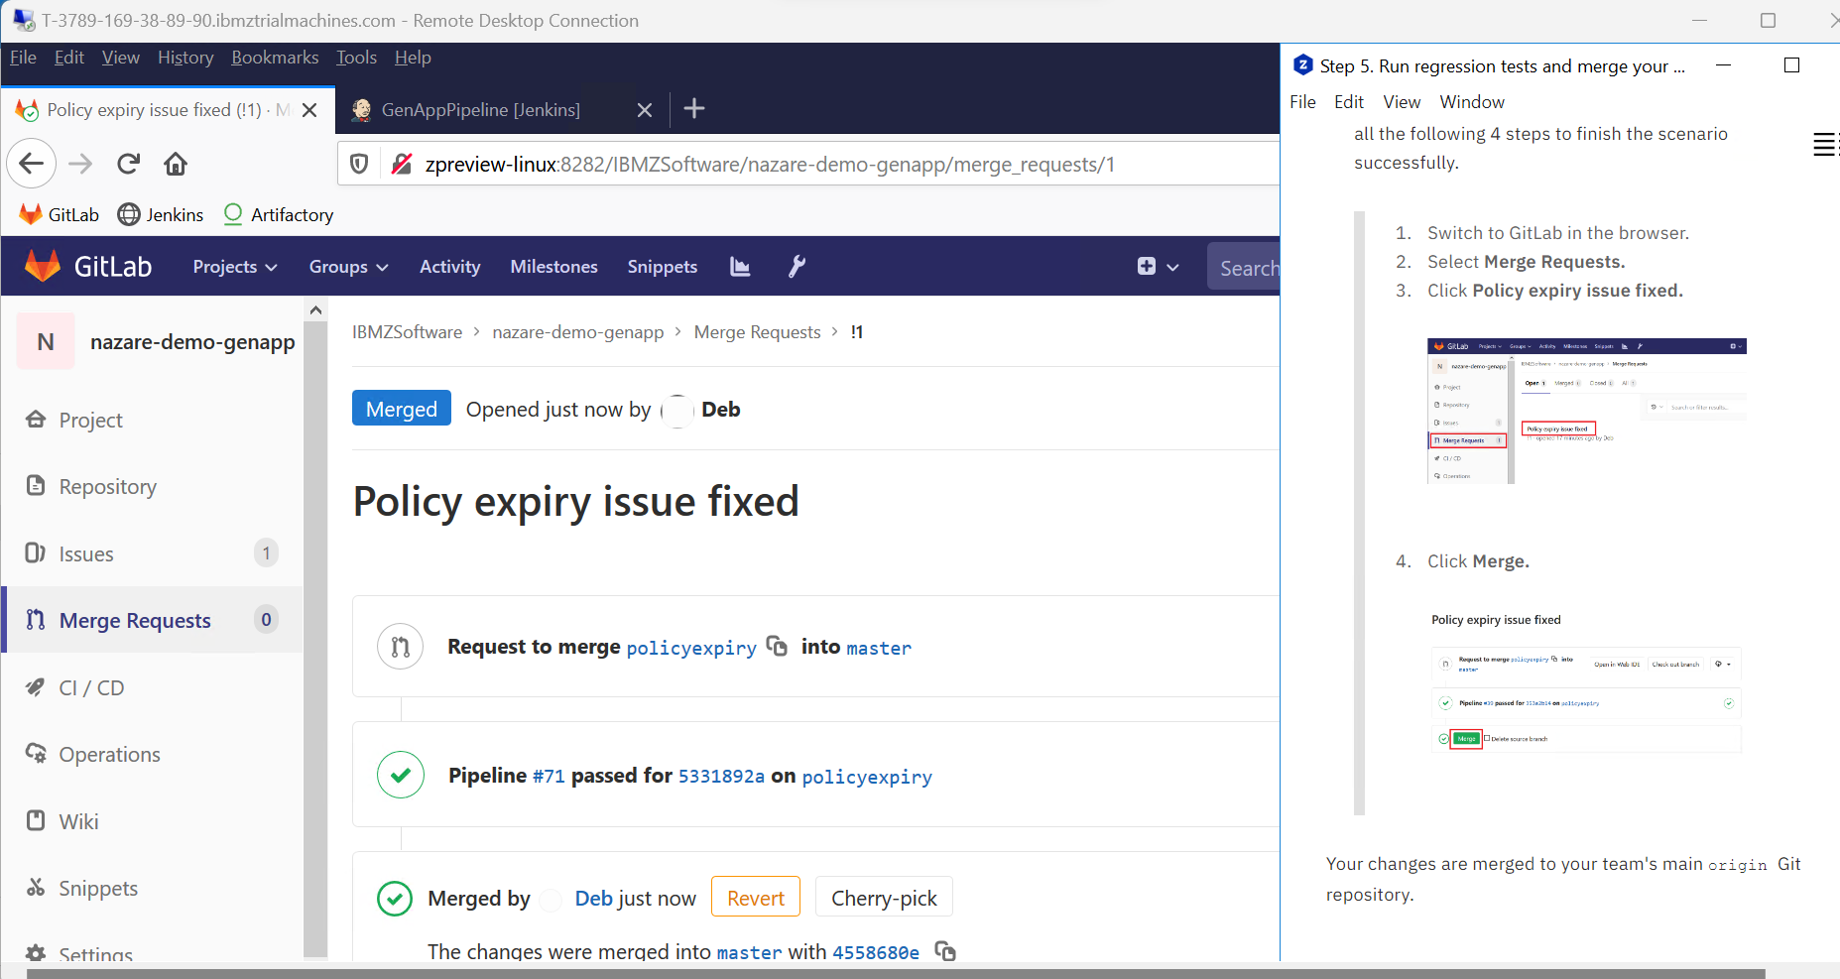

# Scenario#2: WAZI Developer for Eclipse

STEP-1: Check assigned issue and import the application

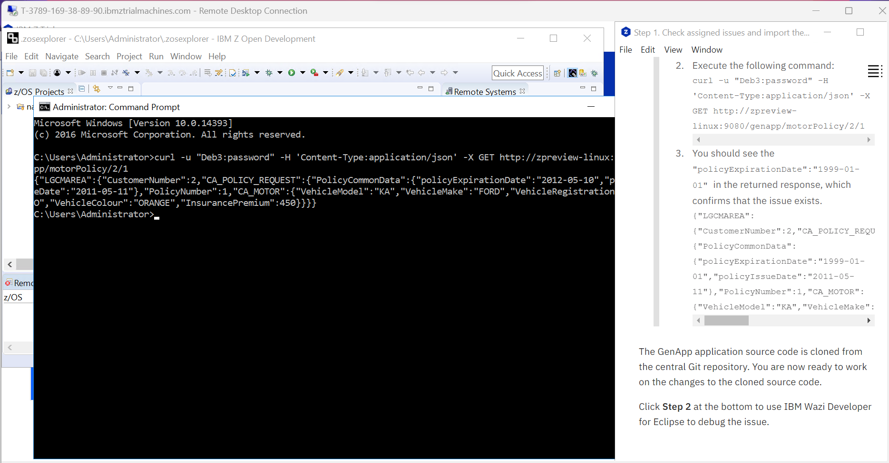

STEP-2: Debugging the Code

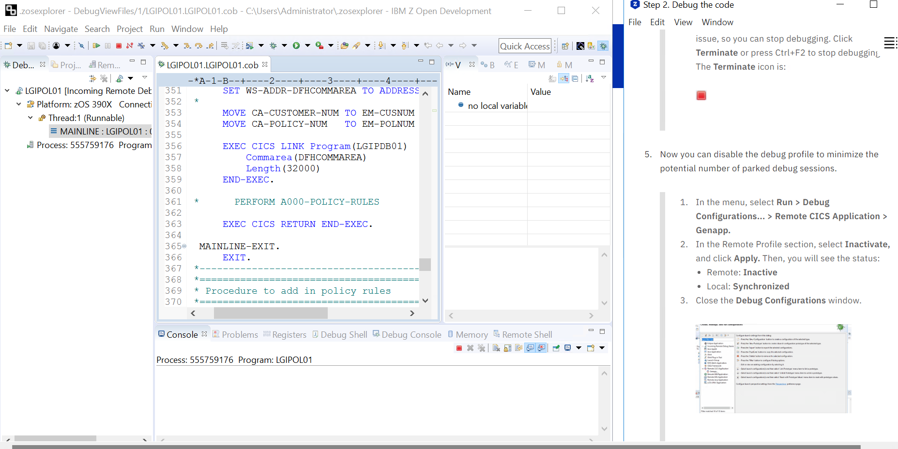

STEP-3: Change the Code

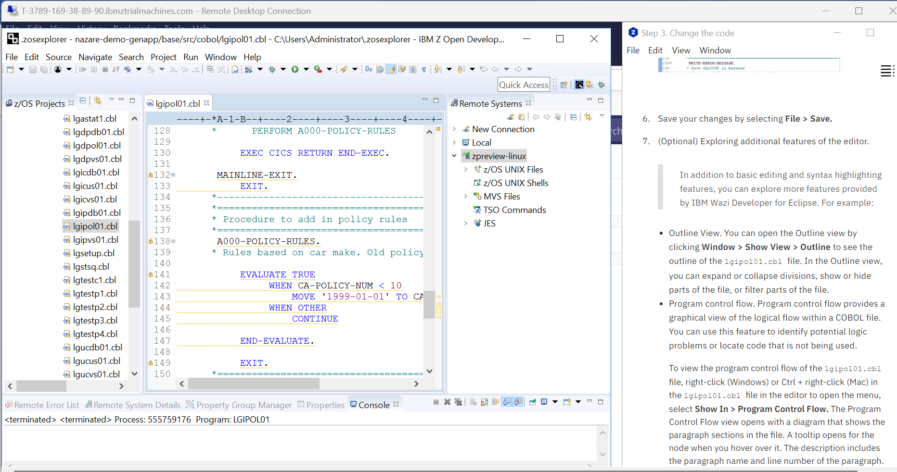

STEP-4: Run a build to test the changed code

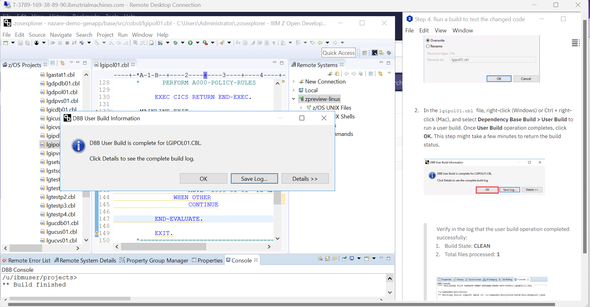

STEP-5: Run Regression test and merge your change

